# Radiation Safety Awareness Training-Non-User

For people at UC Santa Cruz that work in proximity to locations where radioactive materials and/or radiation producing machines are used

### Background Radiation

Everyone on this planet is routinely exposed to background radiation that is naturally occurring. Examples include the sun and stars, uranium in soil and radon gas from the earth. In addition, radiation is routinely used in medicine, research and industry.

As a person who could potentially work near, but not with, radiation or radioactivity, your radiation exposure should be no different than the radiation exposure experienced by the general public.

Examples of Natural and Human-Made Radiation Exposure

Cross Country

U.S. Flight

Chest X-Ray UC Radiation W orker

Natural Background Radiation

CT Scan

3 mrem

10 mrem

10 mrem/year

300 mrem/year 100 mrem - 1000 mrem

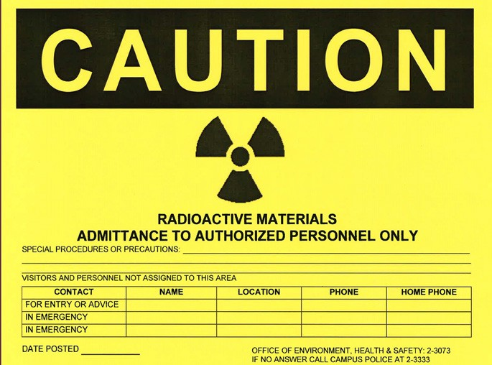

(Above) Radiation Use Door Sign

### Radiation at the University

Radiation producing machines and radioactive materials are common tools used in research and clinical settings. Most academic campuses and medical centers have rooms that are authorized to use radioactivity and have radiation producing machines (e.g. x-ray machines).



UC Santa Cruz has approximately 20 locations authorized to use radioactivity and about 15 radiation producing machines. Around 100 people are authorized to use these materials. These individuals are required to complete routine safety training. Their work is inspected closely for compliance by the radiation safety staff in the Office of Environment, Health & Safety.

The trefoil is the internationally recognized symbol for identifying radiation hazards. All rooms where radioactive materials and radiation producing machines are used or stored are posted with a radiation warning sign on the door entrances. The sign will be yellow with black or magenta and will feature the trefoil. It is safe to enter these areas to do your routine work, unless posted or instructed otherwise.

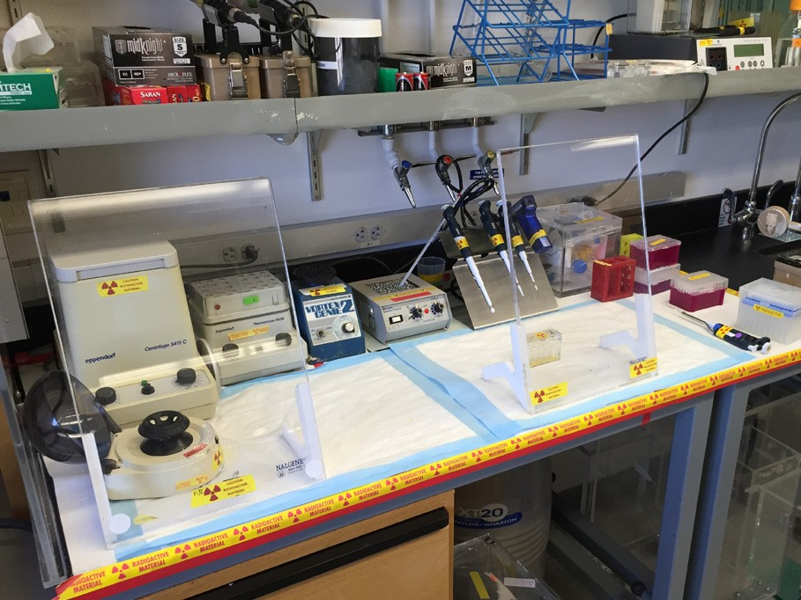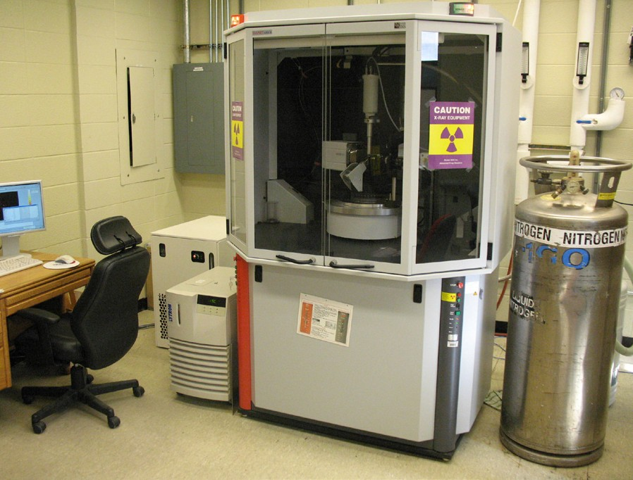It is common to see radiation warning tape with the trefoil symbol on laboratory benches, fume hoods, or specific laboratory equipment like refrigerators, freezers, and centrifuges. These labels denote that these areas may be contaminated with radioactive materials. It is safe to work near these areas, but you should not touch them.

(Left) Radiation W arning Tape around Benchtop; (Right) Radiation Producing Machine

### Work in Posted Rooms

Staff in these settings are trained and authorized to use these materials or machines. Their work is inspected closely for compliance with radiation control regulations by the radiation safety staff to assure that this work is being done safely.

If your work requires you to touch or work in areas labeled as potentially contaminated with radioactivity, please contact Radiation Safety so they can confirm the area is free of radioactive contamination before you start work.

If you have non-routine work to perform (such as repairs, one-time requests, etc.) in rooms posted with radioactive signs, discuss your planned work activity first with the laboratory contact to confirm that it is safe to proceed. If in doubt, contact Radiation Safety for assistance.

Questions or Concerns?

Safety Tips

Do not handle or move materials displaying a radiation label or located inside an area marked with radiation warning tape.

Do not place personal items (tools, cups, etc.) inside areas labeled as potentially contaminated with radioactivity; you risk contaminating the item and yourself.

Do not work in rooms when a radiation producing machine is turned on.

Do not eat or drink in rooms that are posted with a radiation sign.

If you are the last person out of the lab, lock the door.

EH&S Radiation Safety (831) 459-2553

rad.ucsc.edu



Training Record

Please print your name and sign and date this page. Your signature indicates that you have read and understand the information presented in the Radiation Safety Training for Non-Users. If you have any questions about this training, email [rad@ucsc.edu.](mailto:rad@ucsc.edu)

**Name Signature Date**

|  |  |  |
| --- | --- | --- |
| Siuling Pau Sanchez | Email confirmation on file | 4/21/21 |
| Emily Hoang | Email confirmation on file | 4/21/21 |
| Anthony Affolder | Email confirmation on file | 4/22/21 |
| Kirsten Affolder | Email confirmation on file | 4/22/21 |
| Serguei Kachiguine | Email confirmation on file | 4/26/21 |
| Rene Padilla | Email confirmation on file | 5/6/21 |
| Jeff Dror | Email confirmation on file | 5/6//21 |
| Michelle Pichardo Munoz | Email confirmation on file | 3/24/22 |
|  |  |  |
|  |  |  |
|  |  |  |
|  |  |  |
|  |  |  |
|  |  |  |
|  |  |  |
|  |  |  |
|  |  |  |
|  |  |  |
|  |  |  |
|  |  |  |

## Training Record

Please print your name and sign and date this page. Your signature indicates that you have read and understand the information presented in the Radiation Safety Training for Non-Users. If you have any questions about this training, email [rad@ucsc.edu.](mailto:rad@ucsc.edu)

### Name Signature Date

|  |  |  |
| --- | --- | --- |
|  |  |  |
|  |  |  |
|  |  |  |
|  |  |  |
|  |  |  |
|  |  |  |
|  |  |  |
|  |  |  |
|  |  |  |
|  |  |  |
|  |  |  |
|  |  |  |
|  |  |  |
|  |  |  |
|  |  |  |
|  |  |  |
|  |  |  |
|  |  |  |
|  |  |  |
|  |  |  |